A Data Analysis Report On

**“SHOPNEST STORES SALES ”**

As a fulfilment of

**CAPSTONE PROJECT**

**(POWER BI)**

**Submitted By:**

**MOHAMMAD SHAKEEB ULLAH QURESHI**

**Batch No.: DAP-2023-10-1**

**Submitted to:**

**TEAM SKILLOVILLA**

# 

# **ABSTRACT**

**Introduction:**

ShopNest stands as the leading department store in the e-commerce marketplaces in Portugal, serving as a seamless link connecting small businesses from various regions to online channels. In today's dynamic business environment, the importance of data analytics cannot be overstated, particularly in enhancing decision-making and operational efficiency.

**Purpose of the Analysis:**

The purpose of this project is to delve into ShopNest's operations through data analytics, aiming to uncover insights that drive business growth and optimization. By leveraging the power of data, this project seeks to provide ShopNest with actionable insights to improve decision-making and operational effectiveness.

**Scope of the Analysis:**

This project encompasses a comprehensive range of analyses, including but not limited to top categories by total price, delayed orders analysis, monthly comparison of delayed and on-time orders, payment method analysis, product rating analysis, state-wise sales analysis, seasonal sales patterns, and revenue analysis. Each analysis sheds light on different aspects of ShopNest's operations, contributing to a holistic understanding of its performance in the e-commerce marketplace.

**Methodology Overview:**

Power BI is utilized as the primary tool for data analysis and visualization in this project. The dataset used for analysis has been anonymized to ensure confidentiality and privacy. The analytical approach involves a combination of exploratory data analysis, data visualization techniques, and statistical methods to extract meaningful insights from the data.

**Expected Outcomes:**

The expected outcome of this project is to provide ShopNest with valuable insights and strategic recommendations to optimize its operations, enhance customer experience, and drive business growth. By harnessing the insights derived from data analytics, ShopNest can make informed decisions that contribute to its continued success in the e-commerce marketplace.

Contents

**ABSTRACT** 2

**TOP CATEGORIES BY TOTAL PRICE** 3

**DELAYED ORDERS ANALYSIS** 4

**MONTHLY COMPARISON OF DELAYED AND ON-TIME ORDERS** 5

**PAYMENT METHOD ANALYSIS** 5

**PRODUCT RATING ANALYSIS** 6

**STATE-WISE SALES ANALYSIS** 7

**SEASONAL SALES PATTERN** 8

**REVENUE ANALYSIS** 8

**CONCLUSION** 9

# **TOP CATEGORIES BY TOTAL PRICE**

**Question Statement :**

Identify and visually represent the top 10 product categories by total sales

**Visualization :**

**Explanation :**

The bar chart showcases the top 10 product categories by total sales, revealing compelling insights into revenue generation.

Among these categories, Health beauty (beleza_saude) emerges as the top performer, boasting $1.26 million in sales, closely followed by Watches gifts (relogios_presentes) at $1.21 million and Bed bath table (cama_mesa_banho) at $1.04 million. Notably, Sports leisure (esporte_lazer) and Furniture décor (informatica_acessorios) also exhibit strong performance, each surpassing $0.9 million in sales. Ensuingly, Garden tools (Ferramentas_jardim) and Auto (Automotivo) demonstrating sales figures of $0.49 million and $0.59 million, respectively.

The visualization underscores the significance of these top-selling categories, providing valuable guidance for strategic decision-making and resource allocation to capitalize on consumer preferences and maximize revenue potential. These insights into the top-performing product categories offer actionable intelligence for driving business growth and profitability. By leveraging this actionable intelligence, organizations can refine product offerings, tailor promotional campaigns, and nurture customer relationships to drive sustained business success

# **DELAYED ORDERS ANALYSIS**

**Question Statement :**

Determine the number of delayed orders in each category. An order is considered delayed if the actual delivery date is later than the estimated delivery date.

**Visualization :**

**Explanation :**Top of Form

The bar chart provides a comprehensive breakdown of delayed orders across a wide array of product categories, unveiling crucial insights into sales performance and fulfillment efficiency.

Notably, "Bed bath table" emerges as the category with the highest count of delayed orders, totaling **811**, indicating potential challenges in logistics and supply chain management within this segment. Similarly, "Health beauty" and "Sports leisure" exhibit substantial counts of delayed orders, with **775** and **584** respectively, highlighting the need for enhanced coordination and streamlined processes to meet customer expectations promptly. The analysis also reveals significant delays in categories such as "Furniture decor" (**535** delayed orders), "Computers accessories" (**503** delayed orders), and "Watches gifts" (**468** delayed orders), suggesting systemic issues that warrant immediate attention. In contrast, categories like "Diapers and hygiene" and "Flowers" demonstrate minimal instances of delayed orders, with only 1 each respectively, underscoring the efficiency in handling and prompt delivery within these product segments.

Moreover, the visualization facilitates a deeper understanding of the underlying factors contributing to delayed orders, enabling stakeholders to prioritize corrective actions and allocate resources effectively. By discerning patterns and trends across product categories, businesses can identify root causes of delays, whether related to inventory management, transportation logistics, or order processing. For instance, categories such as "Home appliances" (**50** delayed orders) and "Electronics" (**247** delayed orders) may require enhanced inventory forecasting and replenishment strategies to address supply chain bottlenecks and minimize stockouts. Ultimately, the visualization serves as a powerful tool for driving continuous improvement initiatives and fostering a customer-centric approach to business operations in the competitive e-commerce landscape.

# **MONTHLY COMPARISON OF DELAYED AND ON-TIME ORDERS**

**Question Statement :**

Create a dynamic visual that compares the number of delayed orders to the number of orders received earlier for each month. Utilize the drillthrough cross-report feature to provide a detailed analysis of late and on-time deliveries.

**Visualization :**

**Explanation :**

The line chart provides a detailed comparison of delayed and earlier orders across all months, offering valuable insights into order fulfillment performance throughout the year.

Notably, August emerges as the month with the largest disparity between delayed and earlier orders, boasting 11,620 earlier orders compared to a mere 996 delayed orders, showcasing exceptional efficiency in meeting customer demands. Conversely, July records the smallest gap between delayed and earlier orders, with 9,078 earlier orders slightly surpassing 216 delayed orders. The trend continues across the remaining months, with September showing 3,790 earlier orders against 231 delayed, October exhibiting 4,480 earlier orders versus 222 delayed, and November with 4,483 earlier orders compared to 245 delayed. These consistent findings underscore the organization's strong performance in fulfilling orders promptly.

. December and January witness increased delays, with 767 and 667 delayed orders respectively, potentially due to heightened customer demand during the holiday season. Conversely, June and May show relatively fewer delayed orders, with 691 and 696 delayed orders respectively, reflecting efficient order processing and logistics management during these periods. By leveraging these findings, the organization can proactively address operational bottlenecks, optimize resource allocation, and implement targeted strategies to mitigate delays, thereby enhancing customer satisfaction and loyalty.

# **PAYMENT METHOD ANALYSIS**

**Question Statement :**

Analyze the most frequently used payment methods by customers using a visually appealing representation, such as a pie chart or other suitable visuals.

**Visualization :**

**Explanation :**

The pie chart offers a succinct overview of payment types and their distribution among customers, providing key insights into transaction preferences.

Credit card emerges as the most popular payment method, with 76,795 customers opting for this mode of payment, constituting the majority of transactions and representing approximately 73.9% of the customer base. Boleto follows as the second most preferred payment type, with 19,784 customers choosing this method for their purchases, accounting for around 19.0% of the total customers. Additionally, voucher and debit card transactions are represented by 5,775 and 1,529 customers respectively, indicating a smaller yet significant portion of the customer base utilizing these payment options, representing approximately 5.6% and 1.5% of customers respectively. Overall, the visualization highlights the dominance of credit card payments, suggesting a preference for convenience and flexibility among customers.

Furthermore, the pie chart underscores the importance of offering diverse payment options to cater to varying customer preferences and needs. While credit card transactions dominate, the presence of boleto, voucher, and debit card payments indicates the significance of providing alternative payment channels to accommodate different customer demographics and preferences. Additionally, the visualization serves as a valuable tool for decision-makers to allocate resources effectively, prioritize payment processing enhancements, and enhance overall transaction efficiency to meet evolving customer demands and preferences.

# **PRODUCT RATING ANALYSIS**

**Question Statement :**

Determine the top 10 highest-rated products and the bottom 10 lowest-rated products using a bar or column chart.

**Visualization :**

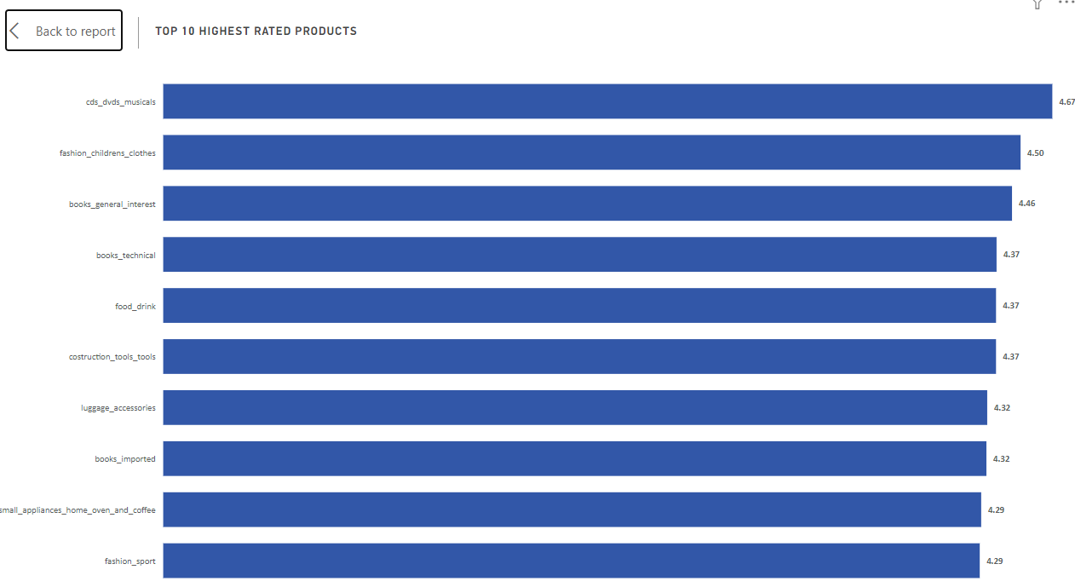

**Explanation :**

The bar chart presents a succinct overview of the top 10 highest-rated product categories based on average customer ratings, offering valuable insights into customer satisfaction and preferences. Topping the list is "CDs, DVDs, and musicals," boasting an impressive average rating of 4.67, indicating exceptional customer satisfaction within this category. Following closely, "Fashion children's clothes" and "Books general interest" secure the second and third positions with average ratings of 4.50 and 4.46 respectively, highlighting the high quality and appeal of these products among customers. Additionally, "Books technical," "Food drink," and "Construction tools tools" share similar average ratings of 4.37, underscoring consistent customer satisfaction across diverse product categories. Notably, "Small appliances home oven and coffee" and "Fashion sport" also garner commendable average ratings of 4.29, suggesting strong positive feedback from customers within these segments. The visualization underscores the importance of product quality and customer experience in driving overall satisfaction and loyalty.

Moreover, the bar chart offers insights into specific product categories that consistently receive high ratings from customers, providing valuable guidance for strategic decision-making and product development initiatives. The presence of "Books imported" and "Luggage accessories" among the top 10 highest-rated products suggests a demand for premium and specialized offerings, while the popularity of "Fashion children's clothes" and "Fashion sport" underscores the significance of style and functionality in consumer preferences. Overall, the visualization serves as a valuable tool for businesses to gauge customer sentiment, refine product offerings, and prioritize investments to enhance overall customer satisfaction and drive sustained business growth.

# **STATE-WISE SALES ANALYSIS**

**Question Statement :**

Identify and visually represent states with high and low sales, providing a clear understanding of regional sales performance.

**Visualization :**

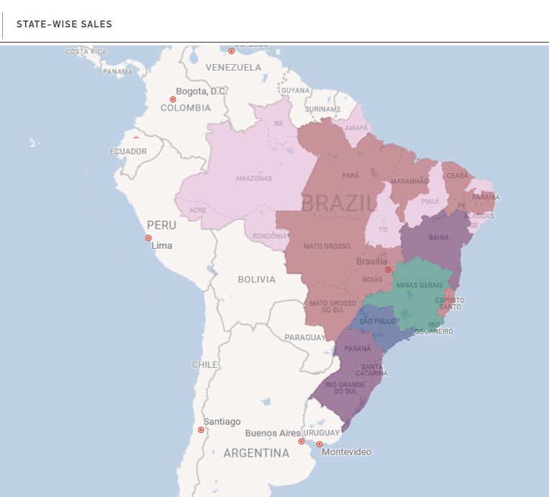

**Explanation :**

The map chart provides a comprehensive overview of sales performance across various states, highlighting notable variations in revenue generation. São Paulo (SP) emerges as the top-performing state, with sales exceeding $5.20 million, representing a substantial 38.3% of the total sales. Rio de Janeiro (RJ) follows closely, exhibiting considerable sales figures, with approximately $1.82 million in revenue, contributing significantly to the overall revenue at 13.4%.

Additionally, Minas Gerais (MG) and Rio Grande do Sul (RS) demonstrate noteworthy sales, with approximately $1.59 million and $0.75 million in revenue, respectively, comprising 11.7% and 5.5% of the total sales. Conversely, states such as Roraima (RR) and Amapá (AP) present lower sales figures falling within the lowest sales bucket. Roraima records sales of $0.007 million, while Amapá registers sales of $0.013 million, with each contributing less than 0.1% to the total revenue.

The map chart's gradient representation showcases states with high, medium, and low sales values, providing clear insights into regional sales trends. It underscores the dominance of key states like São Paulo and Rio de Janeiro in driving overall sales performance, while also highlighting opportunities for growth and expansion in regions with lower sales figures.

Furthermore, the visualization emphasizes the importance of strategic planning and resource allocation to maximize sales potential across different regions. While São Paulo and Rio de Janeiro command significant market shares, states such as Roraima and Amapá present untapped opportunities for growth. This analysis enables decision-makers to gain valuable insights into regional sales trends, guiding strategic planning and operational decisions to optimize sales performance and foster sustainable business growth across diverse geographic regions.

# **SEASONAL SALES PATTERN**

**Question Statement :**

Investigate and visualize any seasonal patterns(Quarterly) or trends in sales data over the course of the year.

**Visualization :**

**Explanation :**

The combo chart provides a comprehensive overview of quarterly sales data across different years, offering valuable insights into sales performance over time.

The bar charts represent year-wise quarter-wise sales, showcasing distinct trends for each quarter. Notably, there is a clear upward trend in sales across all quarters, with significant fluctuations observed between different years. For instance, in the first quarter, sales surged from $0.71 Million in 2017 to $2.7 Million in 2018, indicating substantial growth year over year. Similarly, sales in the second quarter increased from $1.25 Million in 2017 to $2.81 Million in 2018, reflecting continued expansion and market demand. The line chart complements this analysis by illustrating the total sales for each quarter, providing a holistic view of overall sales performance over time.

Furthermore, the combo chart highlights the seasonality of sales, with distinct patterns observed across different quarters. The sum of sales are observed to be highest in the second quarter over the years, with a value of $4.1 Million, followed by Q1 at $3.4 Million and Q3 at $3.3 Million . This seasonal variation underscores the importance of strategic planning and resource allocation to capitalize on peak periods of consumer spending while ensuring consistent performance throughout the year. Overall, the combo chart offers valuable insights into sales trends and seasonality, empowering businesses to make informed decisions and optimize sales strategies to drive sustainable growth.

# **REVENUE ANALYSIS**

**Question Statement :**

Determine the total revenue generated by ShopNest Store  and analyze how it changes over time(Yearly). Represent this information through suitable visuals to highlight trends and patterns.

**Visualization :**

**Explanation :**

The tree chart provides a visual representation of revenue trends across different years, offering insightful observations into revenue performance over time.

Notably, there is a significant increase in revenue from 2016 to 2017, with revenue soaring from $47k in 2016 to $6.92 Million in 2017, showcasing a substantial growth trajectory. This remarkable rise underscores positive market dynamics and the effectiveness of business strategies implemented during that period. Furthermore, the chart reveals a continued upward trend in revenue, with a notable spike to $8.45 Million in 2018, indicating sustained growth and continued success in revenue generation. This significant increase in revenue from 2017 to 2018 highlights the organization's ability to capitalize on opportunities and adapt to changing market conditions, ultimately driving robust financial performance.

# **CONCLUSION**

**Regional Sales Performance:**

By analyzing state-wise sales performance, it's evident that certain regions, such as São Paulo and Rio de Janeiro, significantly contribute to overall revenue generation. Strategic focus on key markets and exploration of growth opportunities in regions with lower sales figures can further bolster sales performance.

**Fulfillment Efficiency:**

The analysis of delayed orders reveals insights into fulfillment efficiency, highlighting potential challenges in logistics and supply chain management. Addressing systemic issues and streamlining processes can enhance order fulfillment and customer satisfaction.

**Seasonal Sales Trends:**

Seasonal sales patterns exhibit distinct trends across different quarters, emphasizing the importance of strategic planning to capitalize on peak periods of consumer spending. Understanding seasonality enables businesses to optimize resource allocation and sales strategies for sustained growth throughout the year.

**Payment Method Preferences:**

Credit card emerges as the dominant payment method, indicating a preference for convenience and flexibility among customers.Offering diverse payment options caters to varying customer preferences and enhances transaction efficiency.

**Product Satisfaction:**

Analysis of product ratings underscores the significance of product quality and customer experience in driving satisfaction and loyalty. Leveraging insights into top-rated products enables businesses to refine offerings and prioritize investments for enhanced customer satisfaction.

**Revenue Growth and Trends:**

Revenue analysis over time reveals substantial growth trajectories, reflecting positive market dynamics and effective business strategies. Continued revenue growth underscores the organization's adaptability and ability to capitalize on opportunities for sustained success.

**Strategic Implications:**

The insights gathered from these analyses provide valuable guidance for strategic decision-making, resource allocation, and operational enhancements.By leveraging actionable intelligence, organizations can refine processes, optimize sales strategies, and drive sustained business growth and profitability in the competitive e-commerce landscape.

In conclusion, a comprehensive understanding of sales performance, fulfillment efficiency, customer preferences, and revenue trends empowers businesses to make informed decisions and implement targeted strategies for sustained success and competitive advantage in the dynamic e-commerce market.